CRM Dashboard-Clients: Click on the Clients button on the left panel.

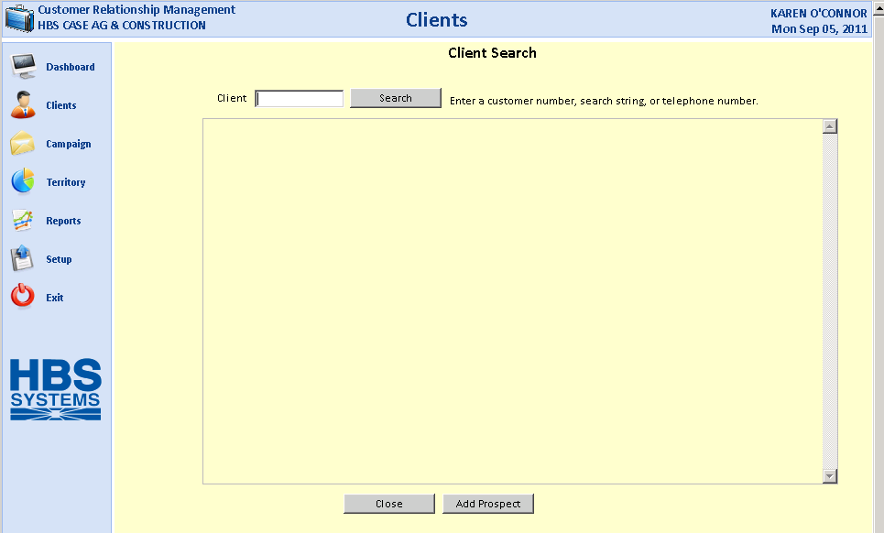

This opens the Client Search screen, where you can search for a customer by:

- Customer number
- Customer name/business name
- Telephone number

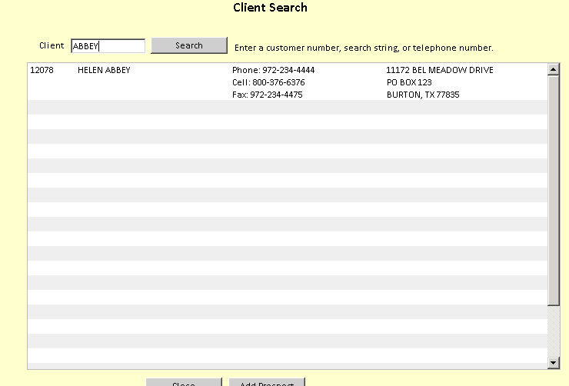

Click on a client from the search list to retrieve the record.

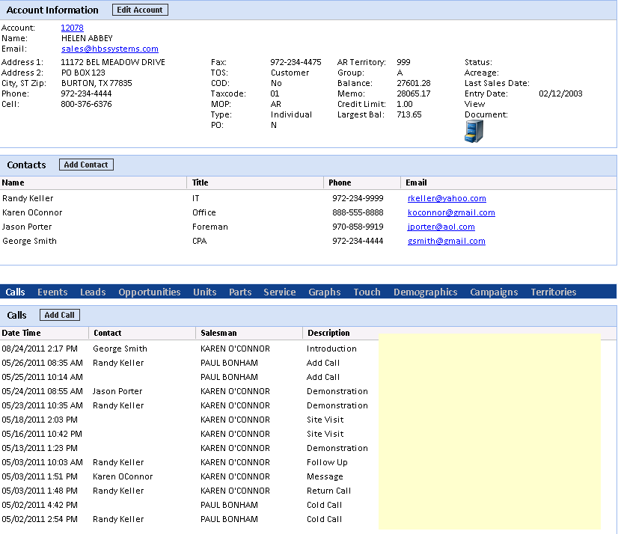

The top panel shows all current base customer info for the account, including:

- Address
- Email address
- Phone numbers
- Balance information

The middle panel lists any contacts for the account. You can also add a contact from this screen by clicking the Add Contact button.

Client Activity Panel: The bottom panel, also known as the Client Activity Panel, shows all activities for this client:

- Calls
- Events
- Leads
- Opportunities
- Units activity
- Parts activity
- Service activity
- Touch (all instances involving this client)
- Demographics
- Campaigns
- Territories

Client Activity Panel-Calls: The default view for the Client Activity Panel is the Call information.

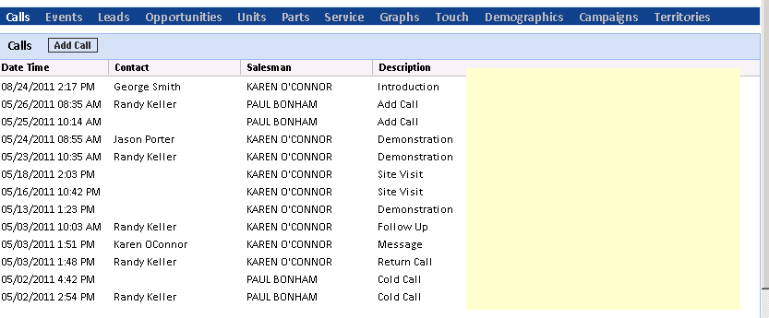

View Call: Click on the line detail to see that call's info.

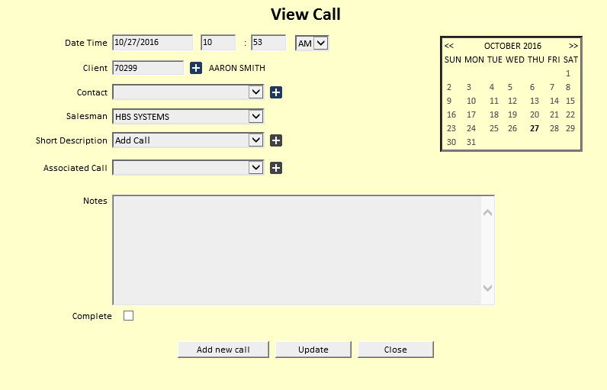

Add Call: You may also add a call from here by clicking on the Add Call button. For more information, see the “Calls” topic for the CRM Dashboard.

Client Activity Panel – Events: Click on Events to see the events for the Client.

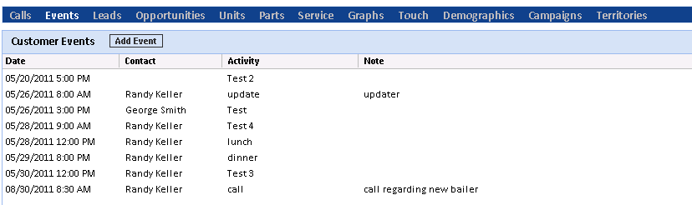

View Event: You can view the details of any Event shown.

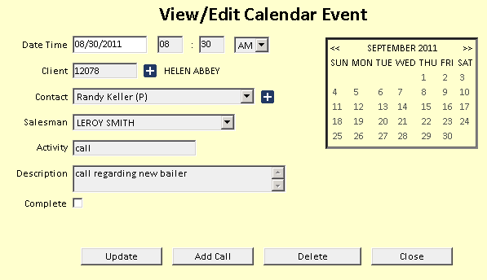

Add Event: You may also add an event by clicking on the Add Event button. For more information, see the “Events” topic for the CRM Dashboard.

Client Activity Panel – Leads: Click on Leads to see the leads for the Client. The Associated Calls are also shown below.

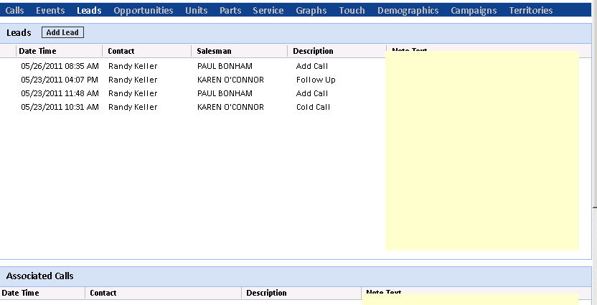

View Lead: You can view the details of any lead shown.

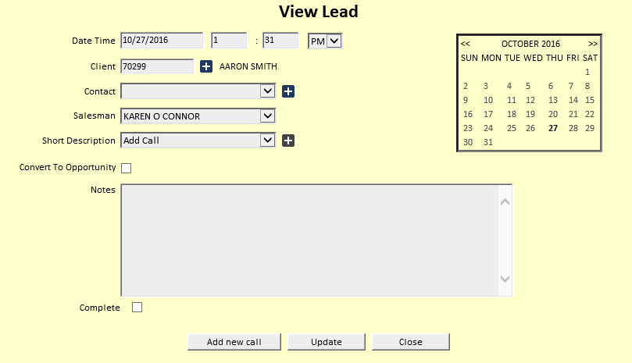

Add Lead: You may also add a lead by clicking on the Add Lead button. For more information, see the “Leads” topic for the CRM Dashboard.

Client Activity Panel-Opportunities: Click on Opportunities to see the opportunities for the Client. The Associated Calls are also shown below.

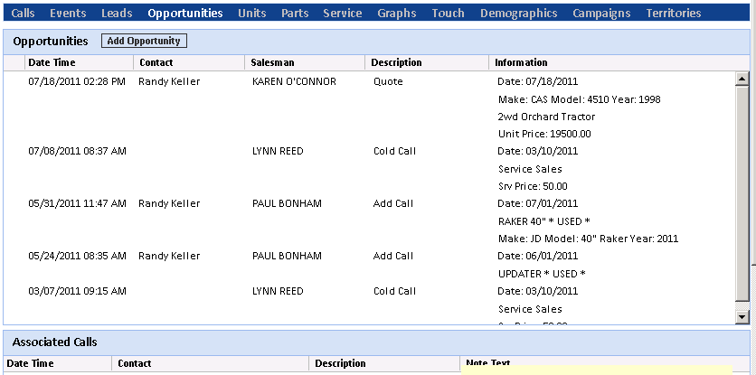

View Opportunity: You can view the details of any opportunity shown by clicking on it.

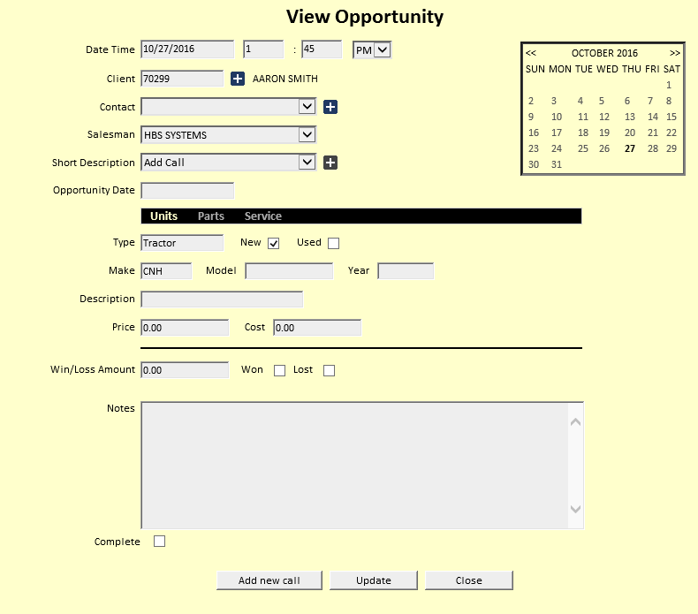

Add Opportunity: You may also add an opportunity by clicking on the Add Opportunity button. For more information, see the “Opportunities” topic for the CRM Dashboard.

Client Activity Panel – Units: Click on Units to see the Client’s Units info. There are 3 groups of Units info:

Customer Equipment Listing (units owned by the client)

Closed Unit Invoices (Unit Sales Invoices)

Unit Quotes (pending quotes for the client)

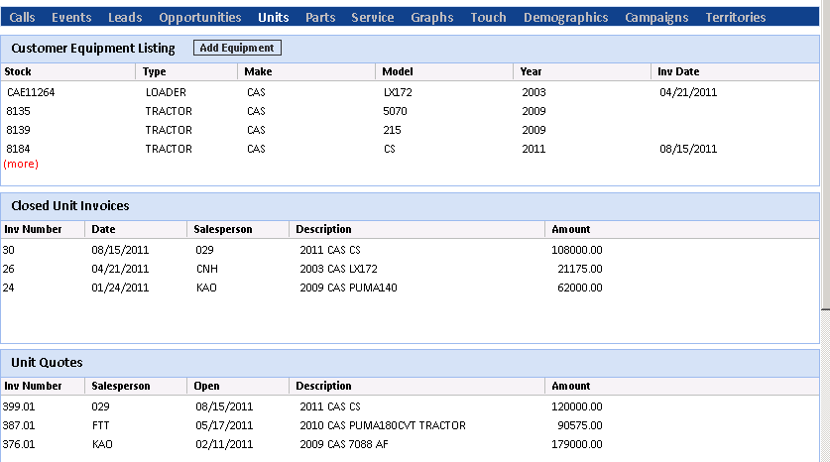

Customer Unit Details: Click on any Stock number to see the details in Unit Inquiry (UI).

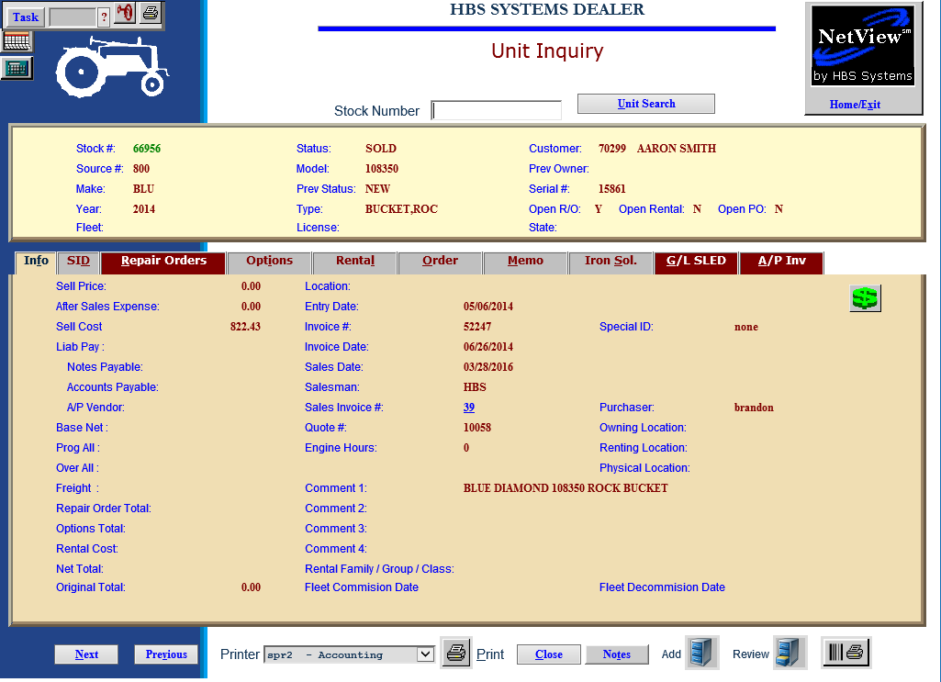

Add Equipment: You can also add a unit in Customer Equipment Maintenance (CEM) by clicking on the Add Equipment button.

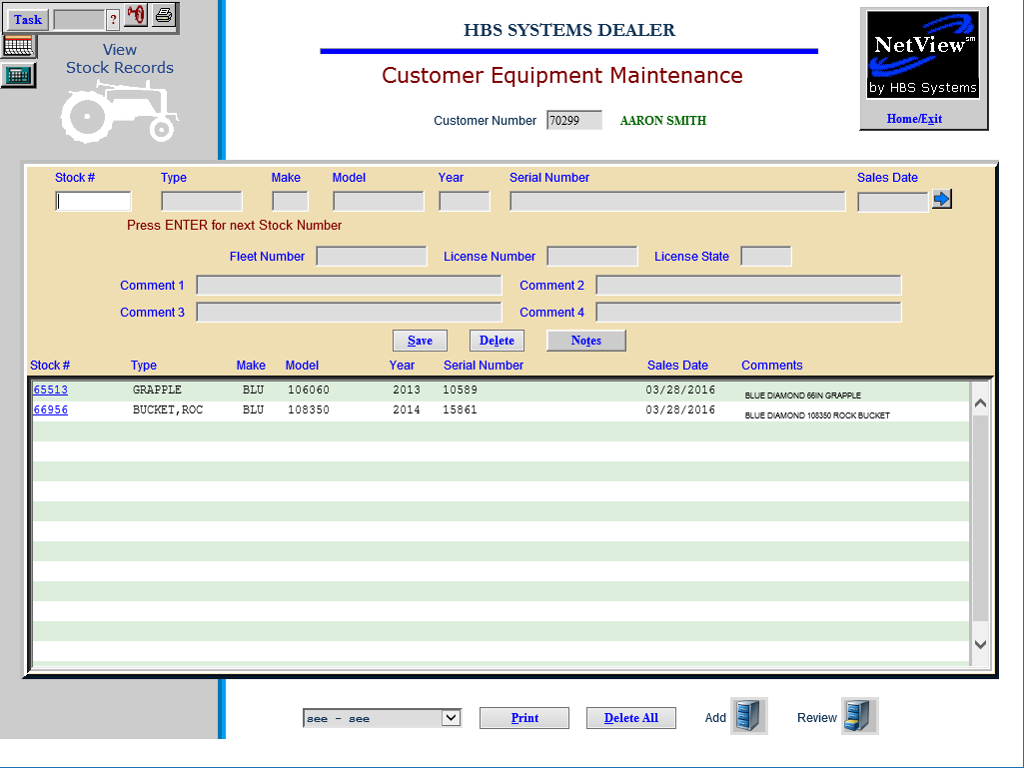

Closed Unit Invoice: Click on any Closed Unit Invoice to see the invoice details.

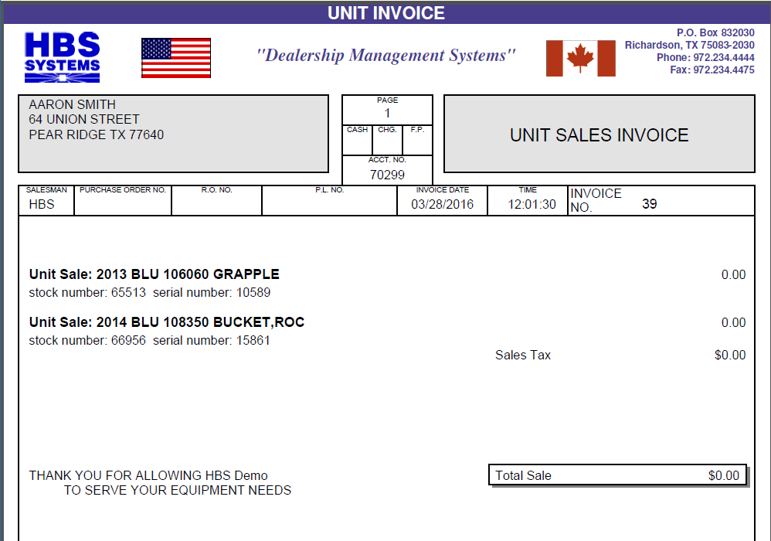

Unit Quote: Click on any Unit Quote to see the quote details.

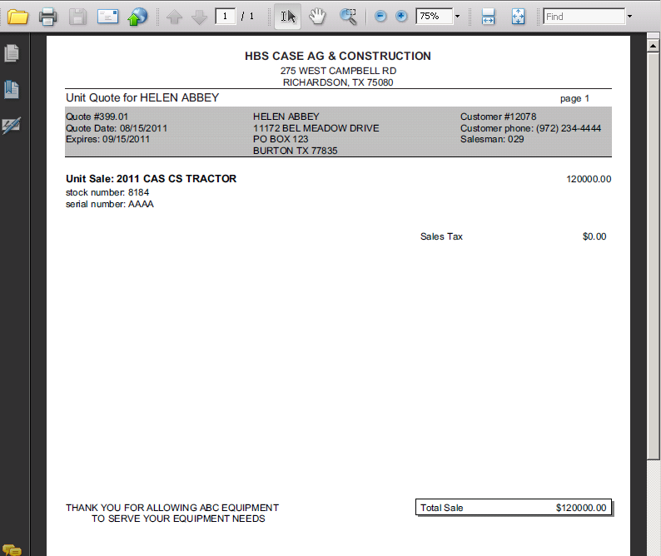

Client Activity Panel – Parts: Click on Parts to see the parts info for the Client. There are 3 groups of Parts info:

Parts Invoices (Parts Sales History)

Open Parts Invoices

Parts Quotes

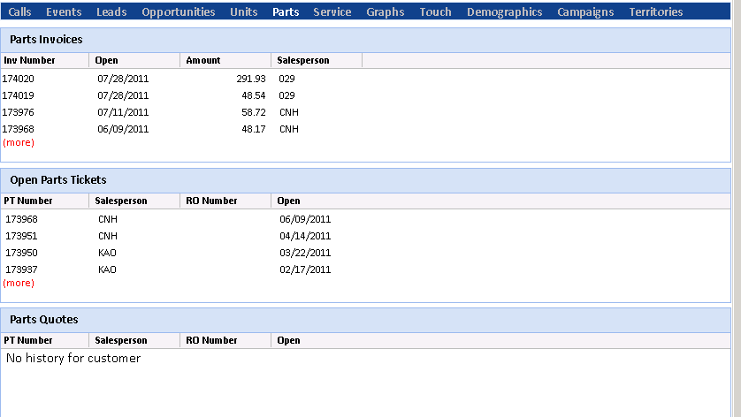

Parts Invoice: Click on any Invoice number to see the details.

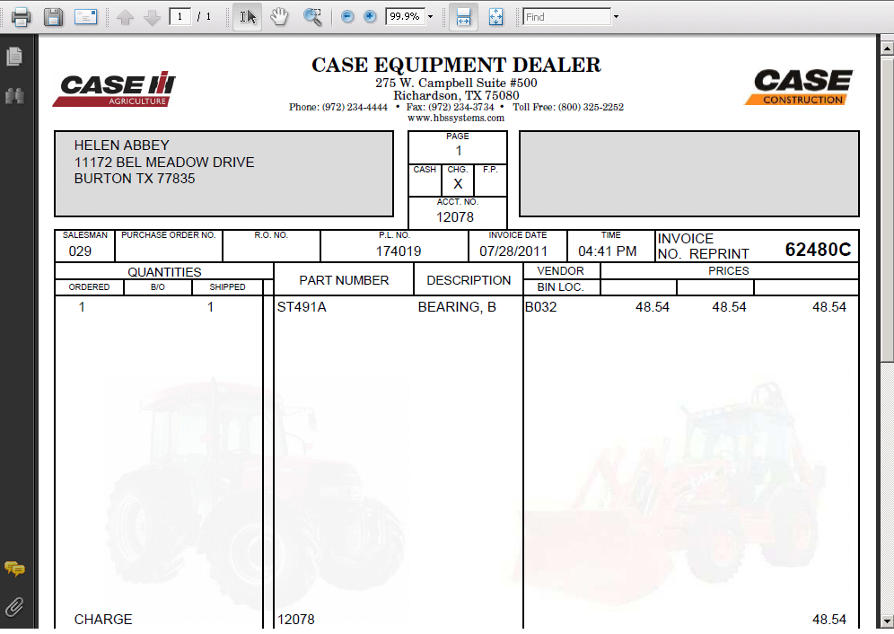

Open Parts Ticket: Click on any Open Parts Ticket to see the details.

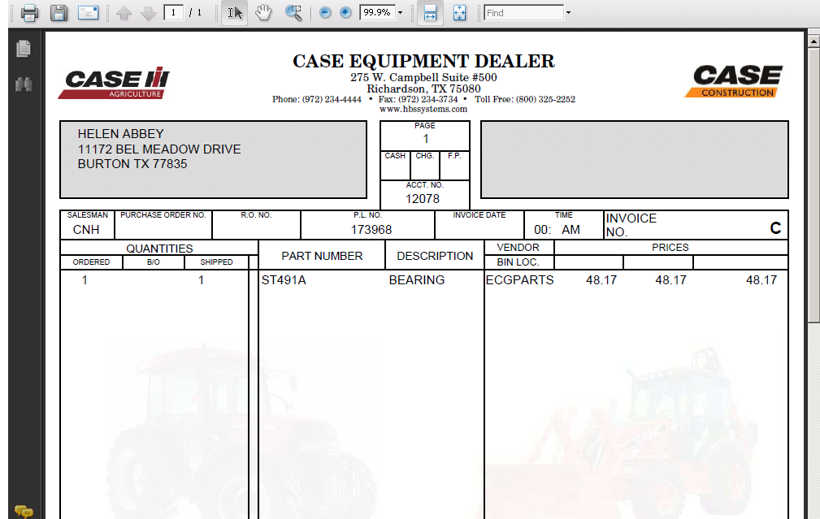

Parts Quote: Click on any Parts Quote to see the details.

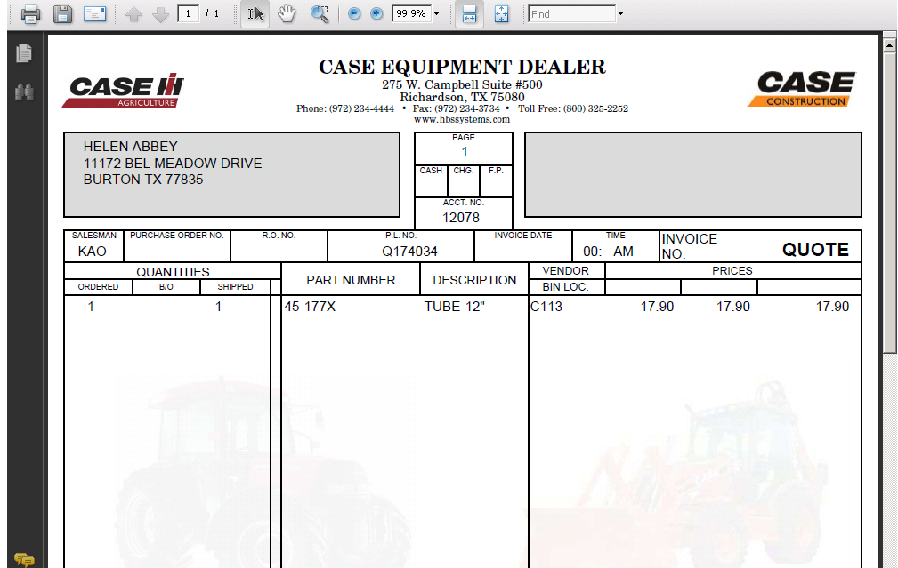

Client Activity Panel – Service: Click on Service to see the service info for the Client. There are 3 groups of Service info:

Service Invoices (Service Sales History)

Open Service Invoices

Service Quotes

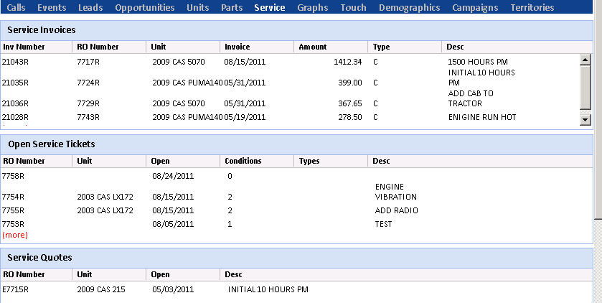

Service Invoice: Click on any Invoice number to see the details.

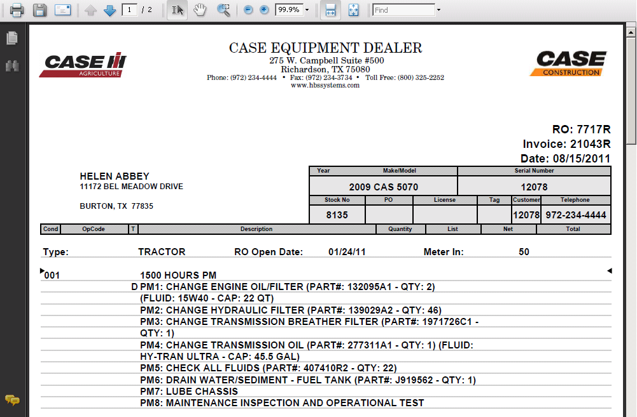

Open Service Ticket: Click on any Open Service Ticket to see the details.

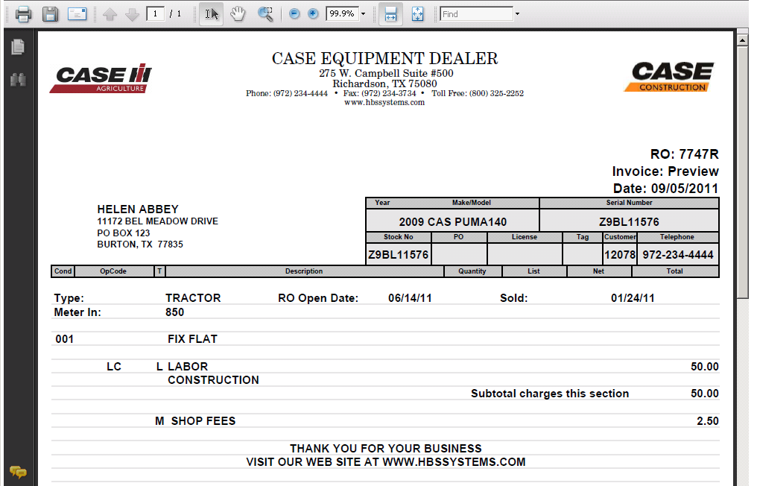

Service Quote: Click on any Service Quote to see the details.

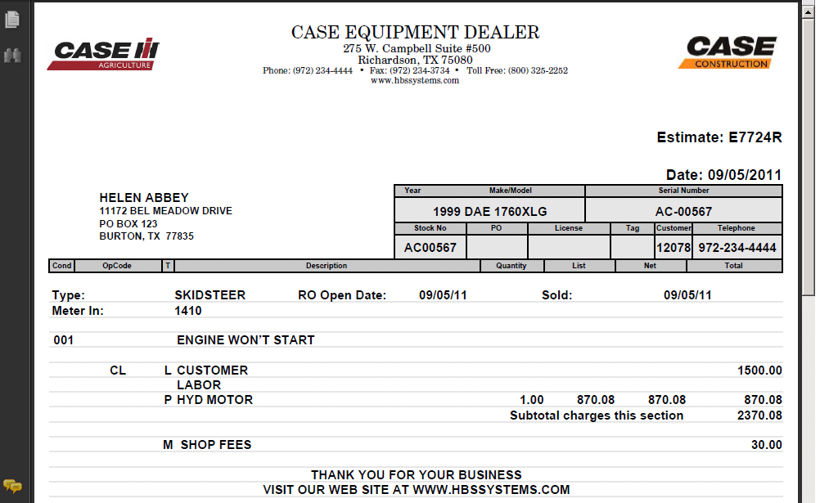

Client Activity Panel – Graphs: Click on Graphs to see the graphs for the Client. There are 3 groups of graphical info:

- Monthly Credit Rating
- Full Sales History (with selectable time periods below)
- Monthly Sales

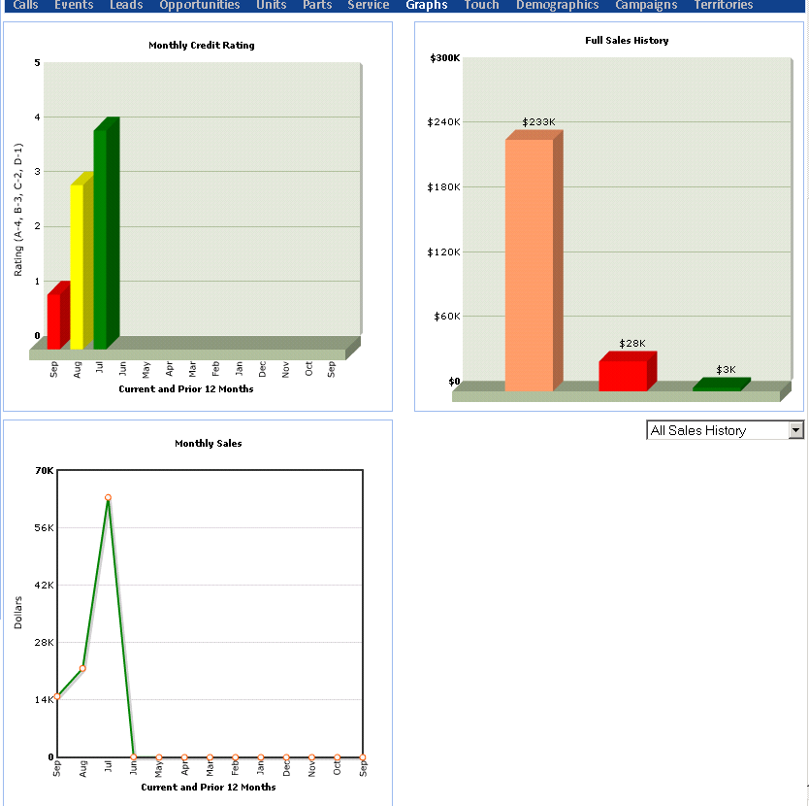

Client Activity Panel – Touch: Click on Touch to see the current activities for the Client. These lines show the current actions involving the client. Depending on the type of action, you may be able to click to see the details of the action.

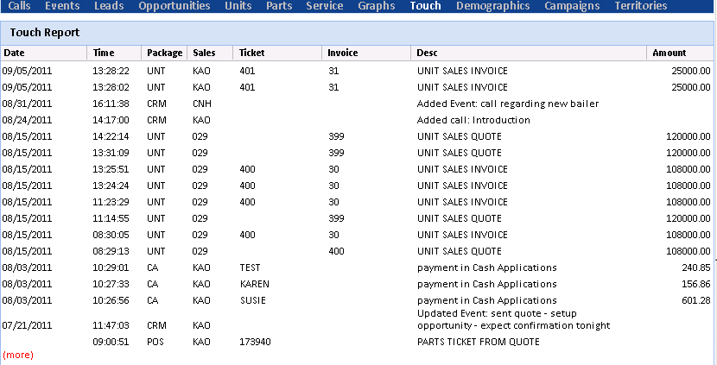

Client Activity Panel – Demographics: Click on Demographics to see this info for the Client. There are 3 groups of demographics:

- Crop (with option to Add Crop)
- Livestock (with option to Add Livestock)
- Other (with option to Add Other)

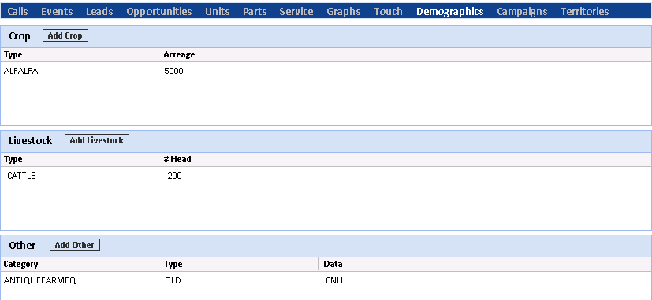

Sample Add Demographics maintenance screen

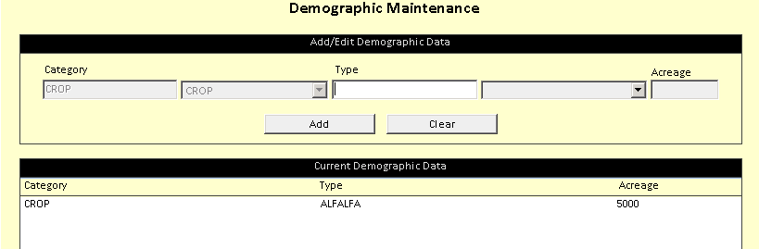

Client Activity Panel – Campaigns: Click on Campaigns to see this info for the Client.

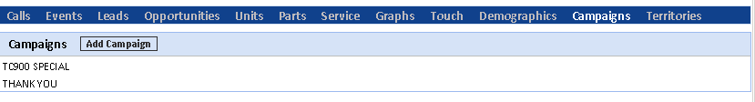

View Campaign: You can view any campaigns that include this client.

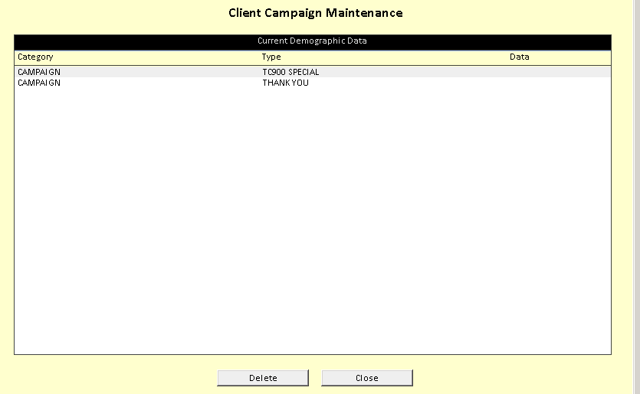

Add Campaign: You can also add a campaign to this client by clicking the Add Campaign button.

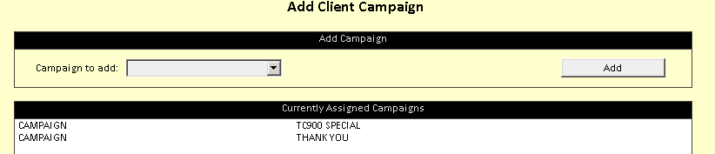

Client Activity Panel – Territories: Click on Territories to see any territories which include the Client.

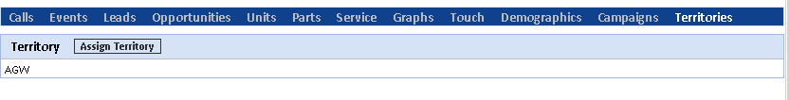
You can also add a territory to this client.

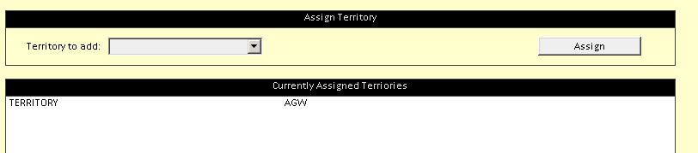

Edit Client Account: You can edit the client record from this screen. Click on the Edit Account button.

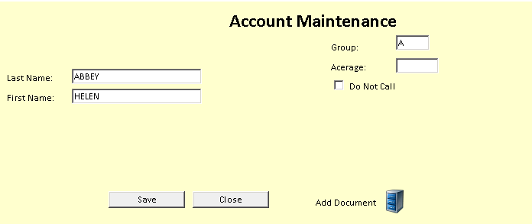

If only this limited information becomes available to edit, it means that the record is resident in ECI (Enter Customer Information). From here, you can edit the first and last name of the record. You can also add or edit the Group ID and the Acreage, as well as check a box to indicate that you do not want to call this client.

Add Prospect: From the client search screen, you may also add a Prospect (a record not kept in ECI). Fill in the base info for the prospect record.

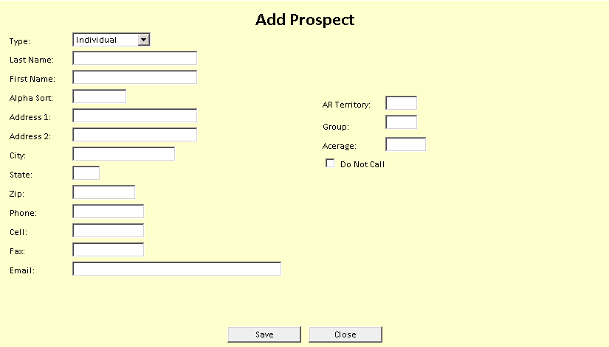

Type: Choose from the following types:

- Individual
- Sole Proprietor
- Corporation
- Government
- Partner
- Rental Yard

Last & First Name: Fill in the info as required.

Alphasort: This 8-character field provides the lookup for the Prospect record.

For an individual, fill in the first 6 letters of the last name followed by the first 2 letters of the first name.

For a company name, fill in the first 8 letters of the name.

Address: Fill in the first and second address fields, city, state, and zip/postal code.

Phone Numbers: Fill in the phone, cell, and fax number fields.

Email: Fill in the email address of the Prospect.

AR Territory: This is a 3-character field for Territory.

Group: This field holds the Group ID for the prospect.

Acreage: Fill in the acreage for the Prospect.

Do Not Call: Check this box if you do not want to call the prospect.

Click on the “Save” button to save the information.

